**WOLAITA SODO UNIVERSITY**



**COLLEGE OF ENGINEERING**

**DEPARTMENT OF ELECTRICAL AND COMPUTER ENGINEERING**

**(COMPUTER STREAM)**

DBS PROJECT: - **LIBRARY MANAGEMENT SYSTEM**

**GROUP MEMBERS**

**NAME ID NO**

**1.MATIWOS DESALEGN………………………………………………………………ENG/R/109/11**

**2.CHERINET SOMANO…………………………………………………………………ENG/R/427/11**

**3. ASTER KIROS…………………………………………………………………………. ENG/R/716/10**

**4. EHITNESH CHIKELU…………………………………………………………………ENG/R/637/11**

**5. EMEBET BEZABIH…………………………………………………………………. ENG/R/437/11**

**SUBMIT TO: - GUYATA**

# ABSTRACT

The library management system is a project which aims in developing a computerized system to maintain all the daily work of the library. This project has many features which are generally not available in normal library management systems like a search book using book title, author name, or ISBN (International Standard Book Number), loan book, reserve book, etc. Online Library Management System is a system that maintains the information about the books present in the library, their authors, the members of the library to whom books are issued, library staff, and all.

This is very difficult to organize manually. Maintenance of all this information manually is a very complex task. Owing to the advancement of technology, the organization of an Online Library becomes much simple. The Online Library Management has been designed to computerize and automate the operations performed over the information about the members, book issues, returns, and all other operations. This computerization of the library helps in many instances of its maintenances. It reduces the workload of management as most of the manual work done is reduced. Overall, this project of ours is being developed to help the students as well as staff of the library to maintain the library in the best way possible and also reduce the human efforts.

Table of Contents Pages

ABSTRACT 2

CHAPTER ONE 1

1. INTRODUCTION 1

1.1. PROJECT AIMS AND OBJECTIVES 1

1.2. BACKGROUND OF PROJECT 1

1.3. SYSTEM ANALYSIS 1

1.4. SOFTWARE REQUIREMENT SPECIFICATION 2

1.4.1. GENERAL DESCRIPTION 2

1.4.2. SYSTEM OBJECTIVES 2

1.4.3. SYSTEM REQUIREMENTS 3

1.4.3.1. NON-FUNCTIONAL REQUIREMENTS 3

1.4.3.2. FUNCTIONAL REQUIREMENTS 3

1.4.4. SOFTWARE REQUIREMENTS 4

EXISTING VS PROPOSED SYSTEM 4

SOFTWARE TOOLS USED 5

CHAPTER TWO 6

2.1. SYSTEM DESIGN 6

2.2. E-R DIAGRAM 7

2.3. CHANGE THE E-R DIAGRAM INTO THE RELATIONS. 8

CHAPTER THREE 9

3.1. SYSTEM IMPLEMENTATION 9

3.2. SQL CODE FOR THE DATABASE 11

# CHAPTER ONE

## INTRODUCTION

This chapter gives an overview of the aim, objectives, background, and operation  
the environment of the system.

## PROJECT AIMS AND OBJECTIVES

The project aims and objectives that will be achieved after completion of this project are  
discussed in this subchapter. The aims and objectives are as follows:

* Can create a computerized management system for a library
* A search column to search the availability of books.
* Can issue books.
* Can store all the book and user data properly.
* Can borrow and return books.
* Tracks the books that users have issued.
* Request column for a librarian for providing new books.

## BACKGROUND OF PROJECT

Library Management System is an application that refers to library systems that are  
generally small or medium in size. It is used by librarians to manage the library using a  
a computerized system where he/she can record various transactions like an issue of books, return of books, the addition of new books, the addition of new students, etc.  
Books and student maintenance modules are also included in this system which would keep track of the students using the library and also a detailed description of the books a library contains. With this computerized system, there will be no loss of book records or member records which generally happens when a non-computerized system is used. All these modules can help librarians to manage the library with more convenience and in a more efficient way as compared to library systems which are not computerized.

## SYSTEM ANALYSIS

we will discuss and analyze the developing process of Library  
Management System including software requirement specification (SRS) and  
comparison between existing and proposed systems. The functional and non-functional  
requirements are included in the SRS part to provide a complete description and overview of system requirements before the developing process is carried out. Besides that, existing  
vs proposed provides a view of how the proposed system will be more efficient than the  
existing one.

## SOFTWARE REQUIREMENT SPECIFICATION

## GENERAL DESCRIPTION

Product Description  
Library Management System is a computerized system that helps  
user(librarian) to manage the library’s daily activity in electronic format. It reduces  
the risk of paperwork such as file loss, file damage, and time-consuming.  
It can help users to manage the transaction or record more effectively and is time-saving.

Problem Statement  
The problem occurred before having a computerized system includes:

* Difficult to search records: -When there is no computerized system there is always a difficulty in searching for records if the records are large in number.
* Space consuming: -After the number of records becomes large the space for physical storage of files and records also increases if no computerized system is implemented.
* Cost consuming: -As there is no computerized system to add each recording paper will be needed which will increase the cost for the management of the library.
* File lost: -When the computerized system is not implemented file is always lost because of the human environment. Sometimes due to some human error, there may be a loss of records.
* File damaged: - When a computerized system is not their file is always lost due to some accident like spilling of water by some member on file accidentally. Besides some natural disasters like floods or fires may also damage the files.

## SYSTEM OBJECTIVES

* Improvement in control and performance: - The system is developed to cope with the current issues and problems of the library.
* Save cost: - After a computerized system is implemented less human force will be required to maintain the library thus reducing the overall cost.
* Save time: - Librarian can search records by using a few clicks of the mouse and a few search keywords thus saving his valuable time.

## SYSTEM REQUIREMENTS

## NON-FUNCTIONAL REQUIREMENTS

* **Product Requirements** :-When a library management system will be implemented librarian and user will easily access the library as searching and book transactions will be very faster.
* **Reliability Requirement**: - The system should accurately perform member registration, member validation, report generation, book transaction, and search.
* **Usability Requirement**: -The system is designed for a user-friendly environment so that students and staff of the library can perform the various tasks easily and in an effective way.
* **Implementation Requirements**: -In implementing the whole system it uses HTML in the front end with PHP as server-side scripting language which will be used for database connectivity and the backend i.e., the database part is developed using MySQL.

## FUNCTIONAL REQUIREMENTS

* **Search Book**: - Description of Feature  
  This feature is found in the book maintenance part. we can search books based on book id, book name, publication, or author name.
* Functional requirements
* The system must be able to search the database based on select search type
* The system must be able to filter book based on keywords entered
* The system must be able to show the filtered book in table view
* **Issue Books and Return Books**: -Description of Feature  
  This feature allows to issue and return books and also view reports of the books issued.
* Functional requirements
* The system must be able to search if the book is available or not before issuing books
* The system must be able to update several books.
* The system must be able to enter issue information in the database.
* The system should be able to enter issue and return date information
* **Register New Book**: -Description of feature  
  This feature allows adding of new books to the library.
* Functional requirements
* The system must be able to verify the information.
* The system must be able to enter several copies into the table.
* The system must be able to not allow two books having the same book id.
* **Register New User: -** Description of feature

This feature can be performed by all users to register a new us to create accounts.

* Functional requirements
* The system must be able to verify information
* System must be able to delete information if the information is wrong

## SOFTWARE REQUIREMENTS

This section describes the software and hardware requirements of the system

**SOFTWARE REQUIREMENTS**

* Operating system- Windows 7 is used as the operating system as it is stable and supports more features and is more user-friendly.
* Database MYSQL-MYSQL is used as a database as it is easy to maintain and retrieve records by simple queries which are in the English language which are easy to understand and easy to write.

## EXISTING VS PROPOSED SYSTEM

* Early days Libraries are managed manually. It required a lot of time to record or retrieve the details. The employees who have to record the details must perform their job very carefully. Even a small mistake would create a lot of problems. Security of information is very less. Report generations of all the information are a very tough task.
* Maintenance of the Library catalog and arrangement of the books to the catalog is a very complex task. In addition to its maintenance of member details, issue dates and return dates, etc. manually is a complex task.
* All the operations must be performed perfectly for the maintenance of the library without any degradation which may finally fail the entire system.
* Book details like authors, number of copies maintained by the library, the recently available number of books, reference books, non-reference books, etc. all this information can be made handy.
* Regarding the member’s designation, several books were issued. Issue dates and returns of each member are maintained separately and fine charged if there is any delay in returning the book.
* The existing system does not have a facility for online reservation of books whereas the proposed system has a facility for online reservation of books.
* The existing system does not have any facility for book requests whereas in the proposed system after logging in to their accounts student can request books.

## SOFTWARE TOOLS USED

MYSQL- **MySQL** ("My S-Q-L", officially, but also called "My Sequel") is (as of July 2013) the world's second most widely used open-source relational database management system (RDBMS). It is named after co-founder Michael Wideness’s daughter, My. The SQL phrase stands for Structured Query Language. The MySQL development project has made its source code available under the terms of the GNU General Public License, as well as under a variety of proprietary agreements. MySQL was owned and sponsored by a single for-profit firm, the Swedish company MySQL AB, now owned by Oracle Corporation. MySQL is a popular choice of database for use in web applications and is a central component of the widely used LAMP open-source web application software stack (and other 'AMP' stacks). LAMP is an acronym for "Linux, Apache, MySQL, Perl/PHP/Python." Free-software-open-source projects that require a full-featured database management system often use MySQL. For commercial use, several paid editions are available and offer additional functionality.

# CHAPTER TWO

## 2.1. SYSTEM DESIGN

**TABLE DESIGN**

Book table for searching books in OPAC.

|  |  |  |  |
| --- | --- | --- | --- |
| Book table | Data type | Default | Key |
| Id | INT | NOT Null | Primary |
| Title | VARCHAR | Null |  |
| Location | INT | Null |  |
| Publication_date | DATE | Null |  |
| Copies_owned | INT | Null |  |

Author table for searching books using author in OPAC.

|  |  |  |  |
| --- | --- | --- | --- |
| Author table | Data type | Default | Key |
| Id | INT | NOT Null | Primary |
| first_name | VARCHAR | Null |  |
| last_name | VARCHAR | Null |  |

Member table for the user library to loan and retrieve books from OPAC.

|  |  |  |  |
| --- | --- | --- | --- |
| Member table | Data type | Default | Key |
| Id | INT | NOT Null | Primary |
| first_name | VARCHAR | Null |  |
| last_name | VARCHAR | Null |  |
| active_status_id | INT | Null |  |

Reservation table for the user to reserve the book in the OPAC.

|  |  |  |  |
| --- | --- | --- | --- |
| Reservation table | Data type | Default | Key |
| Id | INT | NOT Null | Primary |
| book_id | INT | Null |  |
| member_id | INT | Null |  |
| reservation_date_time | DATETIME | Null |  |
| reservation_status_id | INT | Null |  |

Loan table for the user to loan book in the OPAC.

|  |  |  |  |
| --- | --- | --- | --- |
| Loan table | Data type | Default | Key |
| Id | INT | NOT Null | Primary |
| book_id | INT | Null |  |
| member_id | INT | Null |  |
| loan_date_time | DATETIME | Null |  |
| returned_date_time | DATETIME | Null |  |

|  |  |  |  |
| --- | --- | --- | --- |
| Book author table | Data type | Default | Key |
| book_id | INT | Null | Foreign |
| author_id | INT | Null | Foreign |

|  |  |  |  |
| --- | --- | --- | --- |
| Fine table | Data type | Default | Key |
| Id | INT | NOT Null | Primary |
| book_id | INT | Null |  |
| loan_id | INT | Null |  |
| fine_date | DATE | Null |  |

|  |  |  |  |
| --- | --- | --- | --- |
| Fine penalty table | Data type | Default | Key |
| Id | INT | NOT Null | Primary |
| member_id | INT | Null |  |
| penality_date | DATE | Null |  |

|  |  |  |  |
| --- | --- | --- | --- |
| Location table | Data type | Default | Key |
| Id | INT | NOT Null | Primary |
| location_name | VARCHAR | Null |  |

|  |  |  |  |
| --- | --- | --- | --- |
| Reservation status table | Data type | Default | Key |
| Id | INT | NOT Null | Primary |
| status_value | VARCHAR | Null |  |

|  |  |  |  |
| --- | --- | --- | --- |
| Member status table | Data type | Default | Key |
| Id | INT | NOT Null | Primary |
| status_value | VARCHAR | Null |  |

## 2.2. E-R DIAGRAM

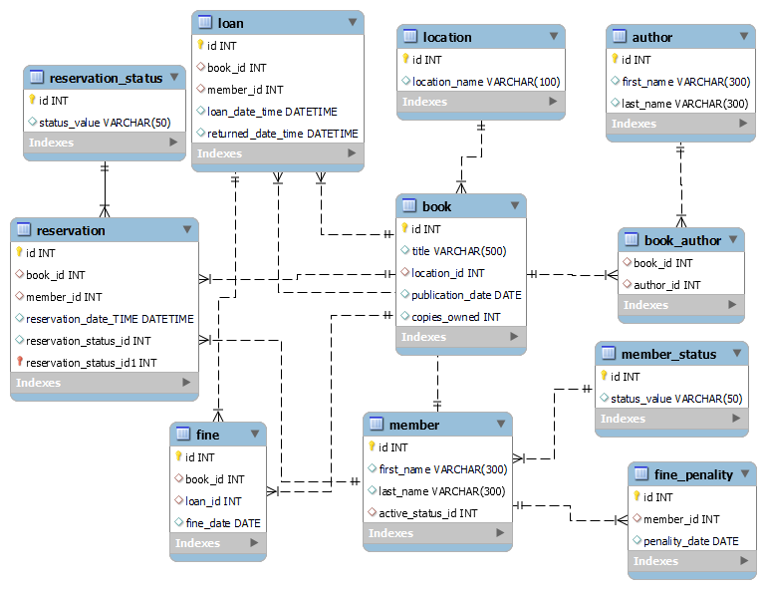

## 2.3. CHANGE THE E-R DIAGRAM INTO THE RELATIONS.

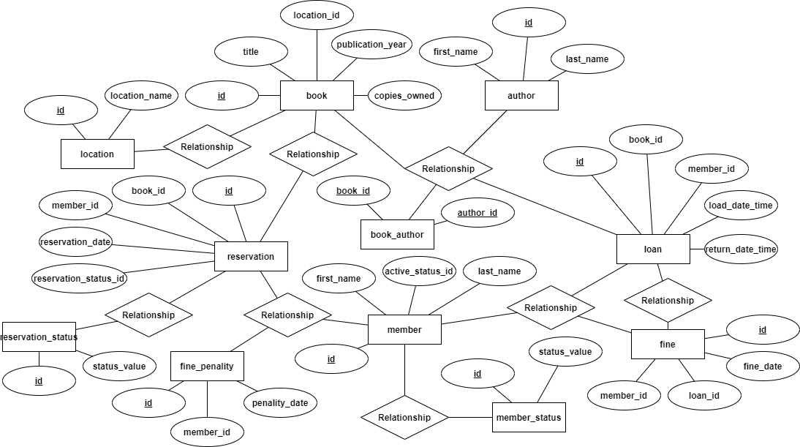

* Another form of relation diagram

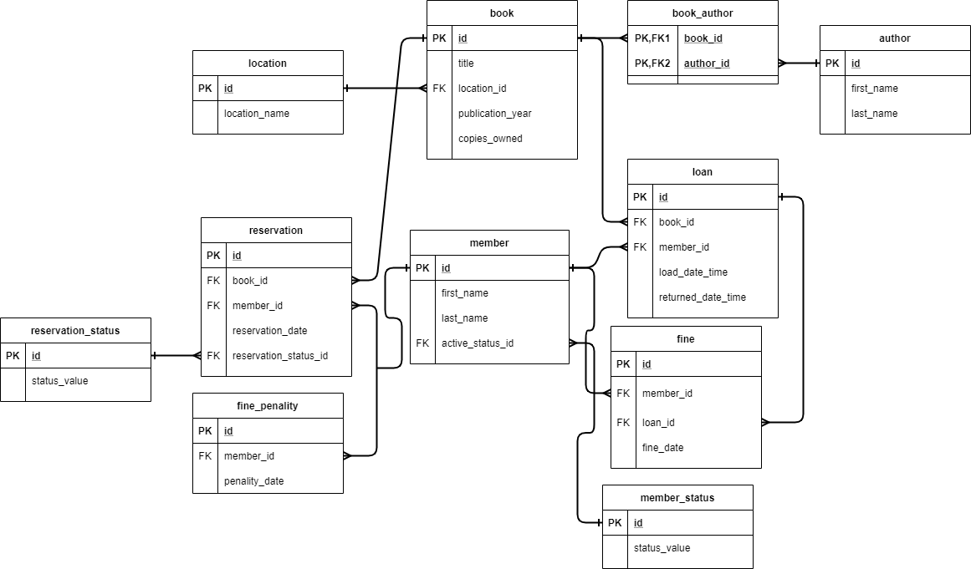

# CHAPTER THREE

## 3.1. SYSTEM IMPLEMENTATION

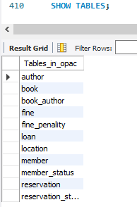**Screenshot for database tables**

**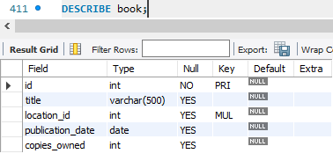  
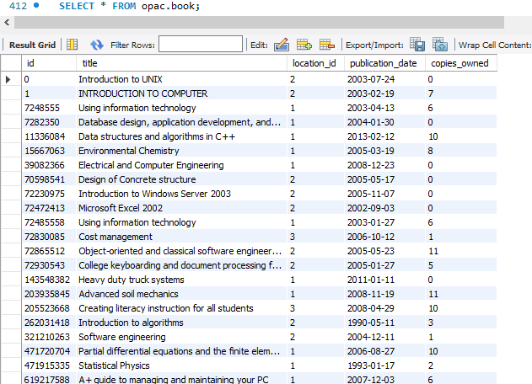**

**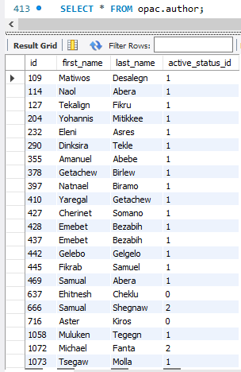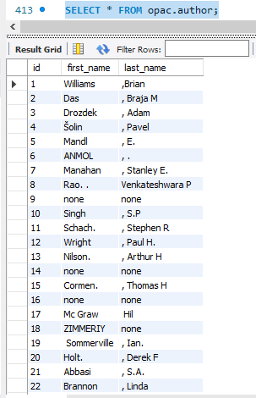  
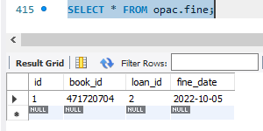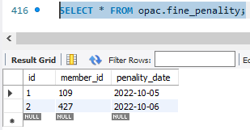**

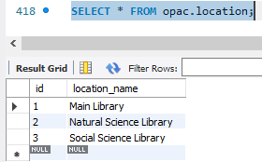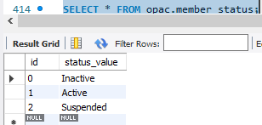

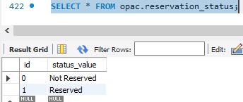 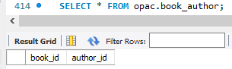

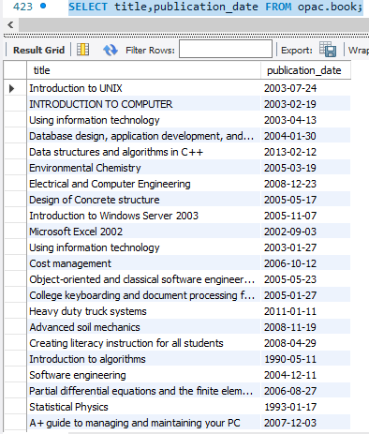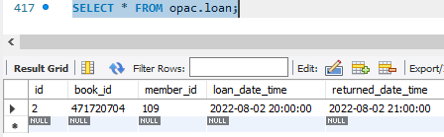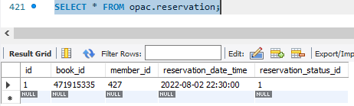

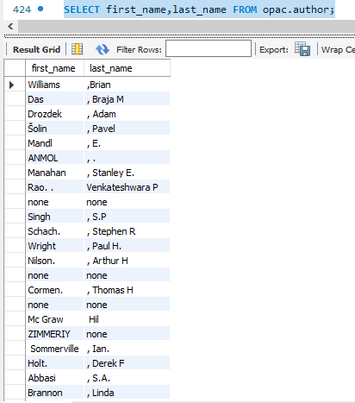

## 3.2. SQL CODE FOR THE DATABASE

Create database OPAC;

use OPAC;

/*

WOLAITA SODO UNIVERSITY LIBRARY - ONLINE PUBLIC ACCESS CATALOG (OPAC)

Create tables for the library management database for WSU Main Library, Natural Science Library and Social Science Library

*/

CREATE TABLE reservation_status (

id INT,

status_value VARCHAR(50),

CONSTRAINT pk_res_status PRIMARY KEY (id)

);

CREATE TABLE location (

id INT,

location_name VARCHAR(100),

CONSTRAINT pk_location PRIMARY KEY (id)

);

CREATE TABLE book (

id INT,

title VARCHAR(500),

location_id INT,

publication_date DATE,

copies_owned INT,

CONSTRAINT pk_book PRIMARY KEY (id),

CONSTRAINT fk_book_location FOREIGN KEY (location_id) REFERENCES location(id)

);

CREATE TABLE author (

id INT,

first_name VARCHAR(300),

last_name VARCHAR(300),

CONSTRAINT pk_author PRIMARY KEY (id)

);

CREATE TABLE book_author (

book_id INT,

author_id INT,

CONSTRAINT fk_bookauthor_book FOREIGN KEY (book_id) REFERENCES book(id),

CONSTRAINT fk_bookauthor_author FOREIGN KEY (author_id) REFERENCES author(id)

);

CREATE TABLE member_status (

id INT,

status_value VARCHAR(50),

CONSTRAINT pk_memberstatus PRIMARY KEY (id)

);

CREATE TABLE member (

id INT,

first_name VARCHAR(300),

last_name VARCHAR(300),

active_status_id INT,

CONSTRAINT pk_member PRIMARY KEY (id),

CONSTRAINT fk_member_status FOREIGN KEY (active_status_id) REFERENCES member_status(id)

);

CREATE TABLE reservation (

id INT,

book_id INT,

member_id INT,

reservation_date_TIME DATETIME,

reservation_status_id INT,

CONSTRAINT pk_reservation PRIMARY KEY (id),

CONSTRAINT fk_res_book FOREIGN KEY (book_id) REFERENCES book(id),

CONSTRAINT fk_res_member FOREIGN KEY (member_id) REFERENCES member(id)

);

CREATE TABLE fine_penality (

id INT,

member_id INT,

penality_date DATE,

CONSTRAINT pk_fine_penality PRIMARY KEY (id),

CONSTRAINT fk_finepen_member FOREIGN KEY (member_id) REFERENCES member(id)

);

CREATE TABLE loan (

id INT,

book_id INT,

member_id INT,

loan_date_time DATETIME,

returned_date_time DATETIME,

CONSTRAINT pk_loan PRIMARY KEY (id),

CONSTRAINT fk_loan_book FOREIGN KEY (book_id) REFERENCES book(id),

CONSTRAINT fk_loan_member FOREIGN KEY (member_id) REFERENCES member(id)

);

CREATE TABLE fine (

id INT,

book_id INT,

loan_id INT,

fine_date DATE,

CONSTRAINT pk_fine PRIMARY KEY (id),

CONSTRAINT fk_fine_book FOREIGN KEY (book_id) REFERENCES book(id),

CONSTRAINT fk_fine_loan FOREIGN KEY (loan_id) REFERENCES loan(id)

);

/*

Insertion of location tells the user which library is the book is available.

*/

insert into location(id, location_name)

values(1, 'Main Library');

insert into location(id, location_name)

values(2, 'Natural Science Library');

insert into location(id, location_name)

values(3, 'Social Science Library');

/*

Insertion of member status tells the librarian the status of the member.

*/

INSERT INTO `OPAC`.`member_status` (`id`, `status_value`)

VALUES ('0', 'Inactive');

INSERT INTO `OPAC`.`member_status` (`id`, `status_value`)

VALUES ('1', 'Active');

INSERT INTO `OPAC`.`member_status` (`id`, `status_value`)

VALUES ('2', 'Suspended');

/*

Insertion of member can help librarian to identify if the member is legal to use the library.

*/

INSERT INTO `OPAC`.`member` (`id`, `first_name`, `last_name`, `active_status_id`)

VALUES ('109', 'Matiwos', 'Desalegn', '1');

INSERT INTO `OPAC`.`member` (`id`, `first_name`, `last_name`, `active_status_id`)

VALUES ('427', 'Cherinet', 'Somano', '1');

INSERT INTO `OPAC`.`member` (`id`, `first_name`, `last_name`, `active_status_id`)

VALUES ('637', 'Ehitnesh', 'Cheklu', '0');

INSERT INTO `OPAC`.`member` (`id`, `first_name`, `last_name`, `active_status_id`)

VALUES ('428', 'Emebet', 'Bezabih', '1');

INSERT INTO `OPAC`.`member` (`id`, `first_name`, `last_name`, `active_status_id`)

VALUES ('716', 'Aster', 'Kiros', '0');

INSERT INTO `OPAC`.`member` (`id`, `first_name`, `last_name`, `active_status_id`)

VALUES ('666', 'Samual', 'Shegnaw', '2');

INSERT INTO `OPAC`.`member` (`id`, `first_name`, `last_name`, `active_status_id`)

VALUES ('1072', 'Michael', 'Fanta', '2');

INSERT INTO `OPAC`.`member` (`id`, `first_name`, `last_name`, `active_status_id`)

VALUES ('355', 'Amanuel', 'Abebe', '1');

INSERT INTO `OPAC`.`member` (`id`, `first_name`, `last_name`, `active_status_id`)

VALUES ('290', 'Dinksira', 'Tekle', '1');

INSERT INTO `OPAC`.`member` (`id`, `first_name`, `last_name`, `active_status_id`)

VALUES ('232', 'Eleni', 'Asres', '1');

INSERT INTO `OPAC`.`member` (`id`, `first_name`, `last_name`, `active_status_id`)

VALUES ('378', 'Getachew', 'Birlew', '1');

INSERT INTO `OPAC`.`member` (`id`, `first_name`, `last_name`, `active_status_id`)

VALUES ('442', 'Gelebo', 'Gelgelo', '1');

INSERT INTO `OPAC`.`member` (`id`, `first_name`, `last_name`, `active_status_id`)

VALUES ('445', 'Fikrab', 'Samuel', '1');

INSERT INTO `OPAC`.`member` (`id`, `first_name`, `last_name`, `active_status_id`)

VALUES ('1058', 'Muluken', 'Tegegn', '1');

INSERT INTO `OPAC`.`member` (`id`, `first_name`, `last_name`, `active_status_id`)

VALUES ('114', 'Naol', 'Abera', '1');

INSERT INTO `OPAC`.`member` (`id`, `first_name`, `last_name`, `active_status_id`)

VALUES ('127', 'Tekalign', 'Fikru', '1');

INSERT INTO `OPAC`.`member` (`id`, `first_name`, `last_name`, `active_status_id`)

VALUES ('469', 'Samual', 'Abera', '1');

INSERT INTO `OPAC`.`member` (`id`, `first_name`, `last_name`, `active_status_id`)

VALUES ('397', 'Natnael', 'Biramo', '1');

INSERT INTO `OPAC`.`member` (`id`, `first_name`, `last_name`, `active_status_id`)

VALUES ('1073', 'Tsegaw', 'Molla', '1');

INSERT INTO `OPAC`.`member` (`id`, `first_name`, `last_name`, `active_status_id`)

VALUES ('410', 'Yaregal', 'Getachew', '1');

INSERT INTO `OPAC`.`member` (`id`, `first_name`, `last_name`, `active_status_id`)

VALUES ('204', 'Yohannis', 'Mitikkee', '1');

/*

Insertion of reservation status tells the librarian if the book is reserved or not.

*/

INSERT INTO `OPAC`.`reservation_status` (`id`, `status_value`)

VALUES ('0', 'Not Reserved');

INSERT INTO `OPAC`.`reservation_status` (`id`, `status_value`)

VALUES ('1', 'Reserved');

/*

Insertion of the book available to the user by their ISBN, title, publication date

Insertion of copies available.

*/

INSERT INTO `opac`.`book` (`id`, `title`, `location_id`, `publication_date`, `copies_owned`)

VALUES ('0072485558', 'Using information technology', '1', '2003-01-27', '6');

INSERT INTO `opac`.`book` (`id`, `title`, `location_id`, `publication_date`, `copies_owned`)

VALUES ('0203935845', 'Advanced soil mechanics', '1', '2008-11-19', '11');

INSERT INTO `opac`.`book` (`id`, `title`, `location_id`, `publication_date`, `copies_owned`)

VALUES ('1133608426', 'Data structures and algorithms in C++', '1', '2013-05-11', '10');

INSERT INTO `opac`.`book` (`id`, `title`, `location_id`, `publication_date`, `copies_owned`)

VALUES ('0471720704', 'Partial differential equations and the finite element method', '1', '2006-08-27', '10');

INSERT INTO `opac`.`book` (`id`, `title`, `location_id`, `publication_date`, `copies_owned`)

VALUES ('0471915335', 'Statistical Physics', '1', '1993-01-17', '2');

INSERT INTO `opac`.`book` (`id`, `title`, `location_id`, `publication_date`, `copies_owned`)

VALUES ('817488344', 'FUNDAMENTALS OF OPTICS', '1', '1996-12-11', '1');

INSERT INTO `opac`.`book` (`id`, `title`, `location_id`, `publication_date`, `copies_owned`)

VALUES ('15667063', 'Environmental Chemistry ', '1', '2005-03-19', '8');

INSERT INTO `opac`.`book` (`id`, `title`, `location_id`, `publication_date`, `copies_owned`)

VALUES ('817622194', 'Dairy farm business management', '1', '2008-02-08', '9');

INSERT INTO `opac`.`book` (`id`, `title`, `location_id`, `publication_date`, `copies_owned`)

VALUES ('813180062', 'principles of Biotechnology ', '1', '2007-11-29', '1');

INSERT INTO `opac`.`book` (`id`, `title`, `location_id`, `publication_date`, `copies_owned`)

VALUES ('817473359', 'Strategic management', '1', '2006-01-13', '9');

INSERT INTO `opac`.`book` (`id`, `title`, `location_id`, `publication_date`, `copies_owned`)

VALUES ('0072865512', ' Object-oriented and classical software engineering', '2', '2005-05-23', '11');

INSERT INTO `opac`.`book` (`id`, `title`, `location_id`, `publication_date`, `copies_owned`)

VALUES ('812652451', ' Highway Engineering', '2', '2004-12-21', '10');

INSERT INTO `opac`.`book` (`id`, `title`, `location_id`, `publication_date`, `copies_owned`)

VALUES ('0070598541', 'Design of Concrete structure', '2', '2005-05-17', '0');

INSERT INTO `opac`.`book` (`id`, `title`, `location_id`, `publication_date`, `copies_owned`)

VALUES ('0072472413', 'Microsoft Excel 2002', '2', '2002-09-03', '0');

INSERT INTO `opac`.`book` (`id`, `title`, `location_id`, `publication_date`, `copies_owned`)

VALUES ('00000000', 'Introduction to UNIX ', '2', '2003-07-24', '0');

INSERT INTO `opac`.`book` (`id`, `title`, `location_id`, `publication_date`, `copies_owned`)

VALUES ('0262031418', 'Introduction to algorithms', '2', '1990-05-11', '3');

INSERT INTO `opac`.`book` (`id`, `title`, `location_id`, `publication_date`, `copies_owned`)

VALUES ('0072230975', 'Introduction to Windows Server 2003 ', '2', '2005-11-07', '0');

INSERT INTO `opac`.`book` (`id`, `title`, `location_id`, `publication_date`, `copies_owned`)

VALUES ('00000001', 'INTRODUCTION TO COMPUTER ', '2', '2003-02-19', '7');

INSERT INTO `opac`.`book` (`id`, `title`, `location_id`, `publication_date`, `copies_owned`)

VALUES ('0072930543', 'College keyboarding and document processing for windows ', '2', '2005-01-27', '5');

INSERT INTO `opac`.`book` (`id`, `title`, `location_id`, `publication_date`, `copies_owned`)

VALUES ('0321210263', 'Software engineering', '2', '2004-12-11', '1');

INSERT INTO `opac`.`book` (`id`, `title`, `location_id`, `publication_date`, `copies_owned`)

VALUES ('1584883723', 'Handbook of Computational Group Theory', '2', '2005-05-17', '0');

INSERT INTO `opac`.`book` (`id`, `title`, `location_id`, `publication_date`, `copies_owned`)

VALUES ('812031902', ' RENEWABLE ENERGY SOURCES AND THEIR ENVIRONMENTAL IMPACT', '3', '2001-08-09', '1');

INSERT INTO `opac`.`book` (`id`, `title`, `location_id`, `publication_date`, `copies_owned`)

VALUES ('813150386', 'Introduction to Health Psychology', '3', '2007-06-25', '14');

INSERT INTO `opac`.`book` (`id`, `title`, `location_id`, `publication_date`, `copies_owned`)

VALUES ('812030709', 'Handbook of Materials Management ', '3', '1994-11-03', '4');

INSERT INTO `opac`.`book` (`id`, `title`, `location_id`, `publication_date`, `copies_owned`)

VALUES ('0205523668', 'Creating literacy instruction for all students', '3', '2008-04-29', '10');

INSERT INTO `opac`.`book` (`id`, `title`, `location_id`, `publication_date`, `copies_owned`)

VALUES ('0631220038', 'Economic development and the division of labor', '3', '2003-03-21', '0');

INSERT INTO `opac`.`book` (`id`, `title`, `location_id`, `publication_date`, `copies_owned`)

VALUES ('0761919716', 'Qualitative research and evaluation methods', '3', '2002-09-16', '0');

INSERT INTO `opac`.`book` (`id`, `title`, `location_id`, `publication_date`, `copies_owned`)

VALUES ('1569020507', 'Constitution for a nation of nations', '3', '1997-01-11', '2');

INSERT INTO `opac`.`book` (`id`, `title`, `location_id`, `publication_date`, `copies_owned`)

VALUES ('818785341', 'Total Wealth', '3', '0000-00-00', '0');

INSERT INTO `opac`.`book` (`id`, `title`, `location_id`, `publication_date`, `copies_owned`)

VALUES ('0072830085', 'Cost management', '3', '2006-10-12', '1');

INSERT INTO `opac`.`book` (`id`, `title`, `location_id`, `publication_date`, `copies_owned`)

VALUES ('1111111111', 'Mentoring-coaching', '3', '2007-12-17', '0');

INSERT INTO `opac`.`book` (`id`, `title`, `location_id`, `publication_date`, `copies_owned`)

VALUES ('0766801799', 'Electrical wiring', '1', '1999-11-27', '0');

INSERT INTO `opac`.`book` (`id`, `title`, `location_id`, `publication_date`, `copies_owned`)

VALUES ('1435483820', 'Careers as an electrician', '1', '1993-07-24', '0');

INSERT INTO `opac`.`book` (`id`, `title`, `location_id`, `publication_date`, `copies_owned`)

VALUES ('143548382', 'Heavy duty truck systems', '1', '2011-01-11', '0');

INSERT INTO `opac`.`book` (`id`, `title`, `location_id`, `publication_date`, `copies_owned`)

VALUES ('1578088054', 'Artificial intelligence in power system optimization', '1', '2013-11-21', '0');

INSERT INTO `opac`.`book` (`id`, `title`, `location_id`, `publication_date`, `copies_owned`)

VALUES ('0852243774', 'Advanced computer Chess 2', '1', '1980-05-27', '0');

INSERT INTO `opac`.`book` (`id`, `title`, `location_id`, `publication_date`, `copies_owned`)

VALUES ('039082366', 'Electrical and Computer Engineering', '1', '2008-12-23', '0');

INSERT INTO `opac`.`book` (`id`, `title`, `location_id`, `publication_date`, `copies_owned`)

VALUES ('1121086144', 'Electrical circuits', '1', '2013-11-19', '0');

INSERT INTO `opac`.`book` (`id`, `title`, `location_id`, `publication_date`, `copies_owned`)

VALUES ('812653613', 'Basic Electrical Engineering', '1', '2013-11-19', '2');

INSERT INTO `opac`.`book` (`id`, `title`, `location_id`, `publication_date`, `copies_owned`)

VALUES ('0849392632', 'Introduction to materials science and engineering', '1', '2007-07-08', '5');

INSERT INTO `opac`.`book` (`id`, `title`, `location_id`, `publication_date`, `copies_owned`)

VALUES ('935014068', 'Fundamentals of electrical engineering', '1', '2010-01-29', '1');

INSERT INTO `opac`.`book` (`id`, `title`, `location_id`, `publication_date`, `copies_owned`)

VALUES ('818845814', 'Electrical machines', '1', '2011-01-13', '0');

INSERT INTO `opac`.`book` (`id`, `title`, `location_id`, `publication_date`, `copies_owned`)

VALUES ('813175456', 'Basic Electrical and Electronics Engineering', '1', '2012-06-18', '7');

INSERT INTO `opac`.`book` (`id`, `title`, `location_id`, `publication_date`, `copies_owned`)

VALUES ('007248555', 'Using information technology', '1', '2003-04-13', '6');

INSERT INTO `opac`.`book` (`id`, `title`, `location_id`, `publication_date`, `copies_owned`)

VALUES ('11336084', 'Data structures and algorithms in C++', '1', '2013-02-12', '10');

INSERT INTO `opac`.`book` (`id`, `title`, `location_id`, `publication_date`, `copies_owned`)

VALUES ('0619217588', 'A+ guide to managing and maintaining your PC', '1', '2007-12-03', '6');

INSERT INTO `opac`.`book` (`id`, `title`, `location_id`, `publication_date`, `copies_owned`)

VALUES ('007282350', 'Database design, application development, and administration', '1', '2004-01-30', '0');

INSERT INTO `opac`.`book` (`id`, `title`, `location_id`, `publication_date`, `copies_owned`)

VALUES ('1118504224', 'Big data for dummies', '1', '2003-11-20', '0');

INSERT INTO `opac`.`book` (`id`, `title`, `location_id`, `publication_date`, `copies_owned`)

VALUES ('1111969604', 'Database systems', '1', '2013-07-12', '0');

INSERT INTO `opac`.`book` (`id`, `title`, `location_id`, `publication_date`, `copies_owned`)

VALUES ('1598632124', 'SQL power', '1', '2007-04-07', '0');

INSERT INTO `opac`.`book` (`id`, `title`, `location_id`, `publication_date`, `copies_owned`)

VALUES ('0672313081', 'SAMS teach yourself database programming with Visual Basic 6 in 21 days', '1', '1999-08-31', '0');

/*

Insertion of the author of the book to help user search book by author name.

*/

INSERT INTO `opac`.`author` (`id`, `first_name`, `last_name`)

VALUES ('1', 'Williams', ',Brian');

INSERT INTO `opac`.`author` (`id`, `first_name`, `last_name`)

VALUES ('2', 'Das', ', Braja M');

INSERT INTO `opac`.`author` (`id`, `first_name`, `last_name`)

VALUES ('3', 'Drozdek', ', Adam');

INSERT INTO `opac`.`author` (`id`, `first_name`, `last_name`)

VALUES ('4', 'Šolin', ', Pavel');

INSERT INTO `opac`.`author` (`id`, `first_name`, `last_name`)

VALUES ('5', 'Mandl', ', E.');

INSERT INTO `opac`.`author` (`id`, `first_name`, `last_name`)

VALUES ('6', 'ANMOL ', ', .');

INSERT INTO `opac`.`author` (`id`, `first_name`, `last_name`)

VALUES ('7', 'Manahan ', ', Stanley E.');

INSERT INTO `opac`.`author` (`id`, `first_name`, `last_name`)

VALUES ('8', 'Rao. .', 'Venkateshwara P');

INSERT INTO `opac`.`author` (`id`, `first_name`, `last_name`)

VALUES ('9', 'none', 'none');

INSERT INTO `opac`.`author` (`id`, `first_name`, `last_name`)

VALUES ('10', 'Singh', ', S.P');

INSERT INTO `opac`.`author` (`id`, `first_name`, `last_name`)

VALUES ('11', 'Schach.', ', Stephen R');

INSERT INTO `opac`.`author` (`id`, `first_name`, `last_name`)

VALUES ('12', 'Wright', ', Paul H.');

INSERT INTO `opac`.`author` (`id`, `first_name`, `last_name`)

VALUES ('13', 'Nilson.', ', Arthur H');

INSERT INTO `opac`.`author` (`id`, `first_name`, `last_name`)

VALUES ('14', 'none', 'none');

INSERT INTO `opac`.`author` (`id`, `first_name`, `last_name`)

VALUES ('15', 'Cormen.', ', Thomas H');

INSERT INTO `opac`.`author` (`id`, `first_name`, `last_name`)

VALUES ('16', 'none', 'none');

INSERT INTO `opac`.`author` (`id`, `first_name`, `last_name`)

VALUES ('17', 'Mc Graw', ' Hil');

INSERT INTO `opac`.`author` (`id`, `first_name`, `last_name`)

VALUES ('18', 'ZIMMERIY', 'none');

INSERT INTO `opac`.`author` (`id`, `first_name`, `last_name`)

VALUES ('19', ' Sommerville', ', Ian.');

INSERT INTO `opac`.`author` (`id`, `first_name`, `last_name`)

VALUES ('20', 'Holt.', ', Derek F');

INSERT INTO `opac`.`author` (`id`, `first_name`, `last_name`)

VALUES ('21', 'Abbasi', ', S.A.');

INSERT INTO `opac`.`author` (`id`, `first_name`, `last_name`)

VALUES ('22', 'Brannon', ', Linda');

INSERT INTO `opac`.`author` (`id`, `first_name`, `last_name`)

VALUES ('23', 'PHL', '.plc');

INSERT INTO `opac`.`author` (`id`, `first_name`, `last_name`)

VALUES ('24', 'Gunning.', ', Thomas G');

INSERT INTO `opac`.`author` (`id`, `first_name`, `last_name`)

VALUES ('25', 'Yang.', ', Xiaokai');

INSERT INTO `opac`.`author` (`id`, `first_name`, `last_name`)

VALUES ('26', ' Patton, Michael ', 'Quinn.');

INSERT INTO `opac`.`author` (`id`, `first_name`, `last_name`)

VALUES ('27', 'Nahum', ', Fasil.');

INSERT INTO `opac`.`author` (`id`, `first_name`, `last_name`)

VALUES ('28', 'Mukerji\'s', ' sanjoy.');

INSERT INTO `opac`.`author` (`id`, `first_name`, `last_name`)

VALUES ('29', 'Hilton', ', Ronald W.');

INSERT INTO `opac`.`author` (`id`, `first_name`, `last_name`)

VALUES ('30', 'Pask', ', Roger.');

INSERT INTO `opac`.`author` (`id`, `first_name`, `last_name`)

VALUES ('31', 'Mullin', ', Ray C.');

INSERT INTO `opac`.`author` (`id`, `first_name`, `last_name`)

VALUES ('32', 'Lytle,', 'Elizabeth Stewart');

INSERT INTO `opac`.`author` (`id`, `first_name`, `last_name`)

VALUES ('33', 'Bennett', ', Sean.');

INSERT INTO `opac`.`author` (`id`, `first_name`, `last_name`)

VALUES ('34', 'Ongsakul', ', Weerakorn.');

INSERT INTO `opac`.`author` (`id`, `first_name`, `last_name`)

VALUES ('35', 'Clarke,', 'M.R.B.');

INSERT INTO `opac`.`author` (`id`, `first_name`, `last_name`)

VALUES ('36', 'Cathey', ', Jim');

INSERT INTO `opac`.`author` (`id`, `first_name`, `last_name`)

VALUES ('37', 'Hanson', ', George');

INSERT INTO `opac`.`author` (`id`, `first_name`, `last_name`)

VALUES ('38', 'Jena,', ' Debashisha');

INSERT INTO `opac`.`author` (`id`, `first_name`, `last_name`)

VALUES ('39', 'Chung,', ' Yip-wah,');

INSERT INTO `opac`.`author` (`id`, `first_name`, `last_name`)

VALUES ('40', 'Singh', ', Tarlok');

INSERT INTO `opac`.`author` (`id`, `first_name`, `last_name`)

VALUES ('41', 'Gupta,', 'J.B.');

INSERT INTO `opac`.`author` (`id`, `first_name`, `last_name`)

VALUES ('42', 'Bhattacharya,', 'S.K.');

INSERT INTO `opac`.`author` (`id`, `first_name`, `last_name`)

VALUES ('43', ' Williams,', 'Brian K.,');

INSERT INTO `opac`.`author` (`id`, `first_name`, `last_name`)

VALUES ('44', ' Drozdek,', ' Adam.,');

INSERT INTO `opac`.`author` (`id`, `first_name`, `last_name`)

VALUES ('45', 'Andrews,', 'Jean');

INSERT INTO `opac`.`author` (`id`, `first_name`, `last_name`)

VALUES ('46', 'Mannino,', 'Michael V.');

INSERT INTO `opac`.`author` (`id`, `first_name`, `last_name`)

VALUES ('47', 'Hurwitz,', 'Judith.');

INSERT INTO `opac`.`author` (`id`, `first_name`, `last_name`)

VALUES ('48', 'Coronel,', ' Carlos');

INSERT INTO `opac`.`author` (`id`, `first_name`, `last_name`)

VALUES ('49', 'Hess', 'Kenneth.');

INSERT INTO `opac`.`author` (`id`, `first_name`, `last_name`)

VALUES ('50', 'Smith,', 'Curtis');

/*

Insertion of reservation helps the user to reserve the book.

*/

INSERT INTO `opac`.`reservation` (`id`, `book_id`, `member_id`, `reservation_date_time`, `reservation_status_id`)

VALUES ('1', '0471915335', '427', '2022-08-02 22:30:00', '1');

/*

Insertion of loan helps the user to loan book for some time.

*/

INSERT INTO `opac`.`loan` (`id`, `book_id`, `member_id`, `loan_date_time`, `returned_date_time`)

VALUES ('2', '0471720704', '109', '2022-08-02 20:00:00', '2022-08-02 21:00:00');

/*

Insertion of fine help to fine user that did not return the book on time.

*/

INSERT INTO `opac`.`fine` (`id`, `book_id`, `loan_id`, `fine_date`)

VALUES ('1', '471720704', '2', '2022-10-05');

/*

Insertion of fine penalty help to fine user that did not return the book on time for three days.

*/

INSERT INTO `opac`.`fine_penality` (`id`, `member_id`, `penality_date`)

VALUES ('1', '109', '2022-10-05');

INSERT INTO `opac`.`fine_penality` (`id`, `member_id`, `penality_date`)

VALUES ('2', '427', '2022-10-06');

SHOW TABLES;

DESCRIBE book_author;

SELECT * FROM opac.book;

SELECT * FROM opac.author;

SELECT * FROM opac.book_author;

SELECT * FROM opac.fine;

SELECT * FROM opac.fine_penality;

SELECT * FROM opac.loan;

SELECT * FROM opac.location;

SELECT * FROM opac.member;

SELECT * FROM opac.member_status;

SELECT * FROM opac.reservation;

SELECT * FROM opac.reservation_status;